User Guide

**HPE SSD Selector V2.0.1**

**Introduction**

SSD selector helps the customer to choose the right SSD for their needs. In this documentation explain the product and its features.

**What is SSD?**

SSD – Solid State Drive is a new generation of storage device. It is Significantly faster due to their low read access time and fast throughputs.

**How HPE is Support for SSD?**

HPE is support their Customer to select the SSD based on the workload, Server type, Drive Capacity, Interface, and Form factor.

**Search the SSD Based on the Server type and Server Model**

If the Customer knows what they are looking for in the search box, they can enter the search keyword column fill with Option SKUID. It will display the exact SSD or else change the server type and server model based on that the result will display. Also, we can adjust the slider to get the required SSD.

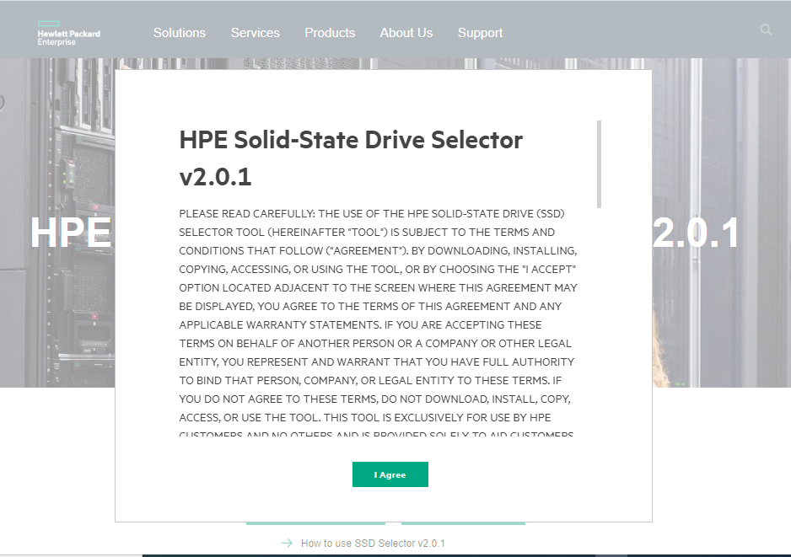

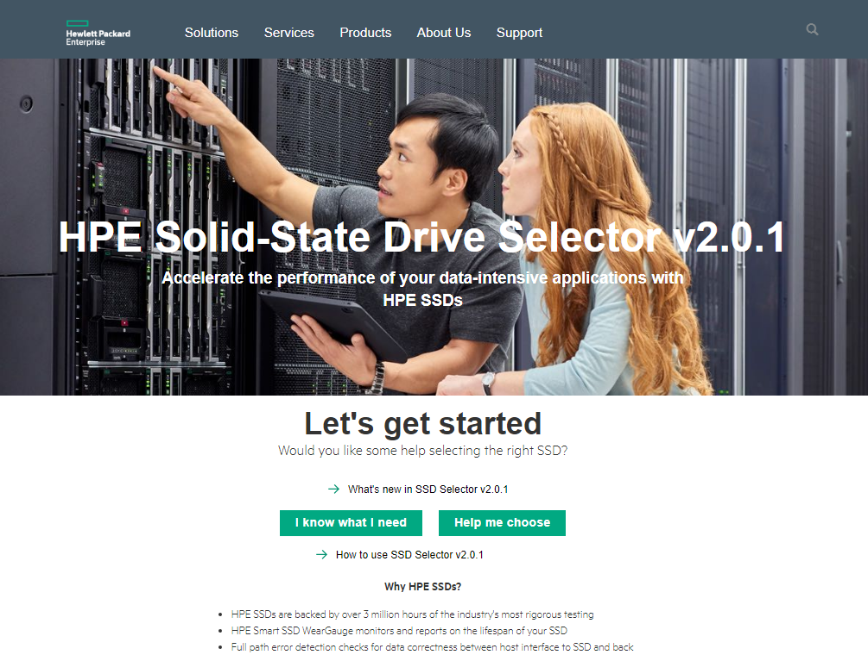 The result page can directly see from home page by clicking **I know what I need**, or else if we do not know what to search, we can click **Help Me Choose** option from home page.

**Fig 1.1: Home Page**

**Help me Choose Option**

* 1. Help me to choose option will redirect to workload page. This page contains 4 options Read option, Read/Write option, write option and Very Read Optimized, Refer Figure 1.2 (a)

**Very Read Optimized (VRO): - Workloads** such as Real-time Analytics, Content Delivery, and Large Block Database & BI are considered VERY READ performance driven. For good VERY READ performance, select Very Read Optimize (VRO) SSDs.

**Read Intensive: -** A read-intensive solid-state drive (SSD) is a storage or caching device intended for use with applications that write data infrequently. Workloads such as web servers, social media, and boot are considered READ performance driven. For good READ performance, select Read Intensive (RI) SSDs.

**Mixed Use (Read/Write): -** Workloads with balanced READ and WRITE needs are considered mixed use. For a good balance of performance and price, select Mixed Use (MU) SSDs.

**Write Intensive: -** Workloads such as big data analytics, virtualization or business intelligence are considered WRITE performance driven. For the best performance, select Write Intensive (WI) SSDs.

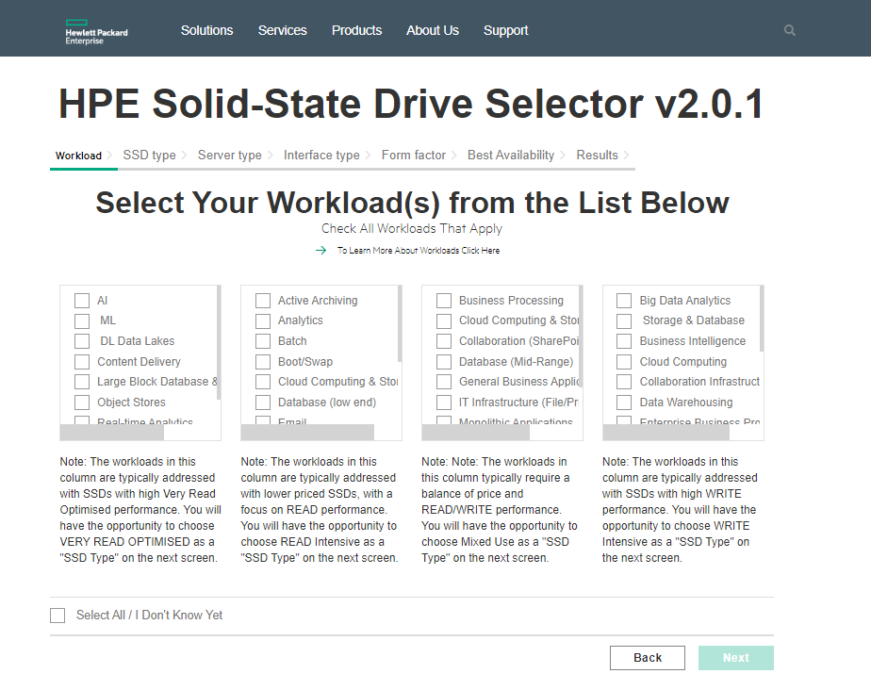

**Fig 1.2: Workload Page (a)**

* 1. Select the Workload based on the requirement, select the workload from the Very Read Optimized column/ Read/Mixed/Write performance and Workload selected Refer Fig 1.2 (b)

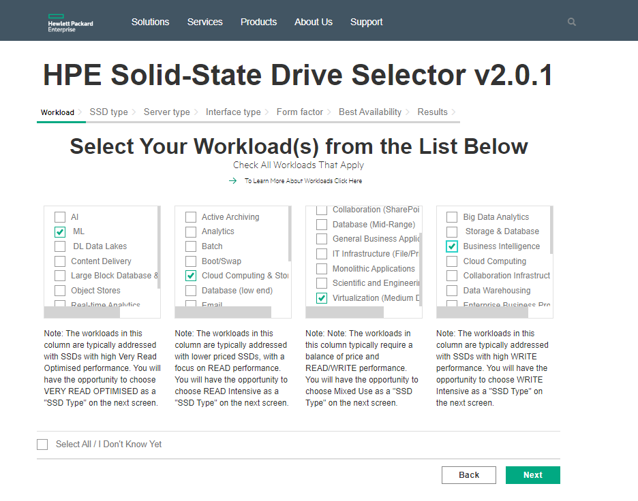

**Fig 1. 2 Workload Page (b)**

* 1. “Select All/ I Don’t Know Yet”, This option is to select all options when user do not know about the Workload. Select All Refer Fig 1.2 (c)

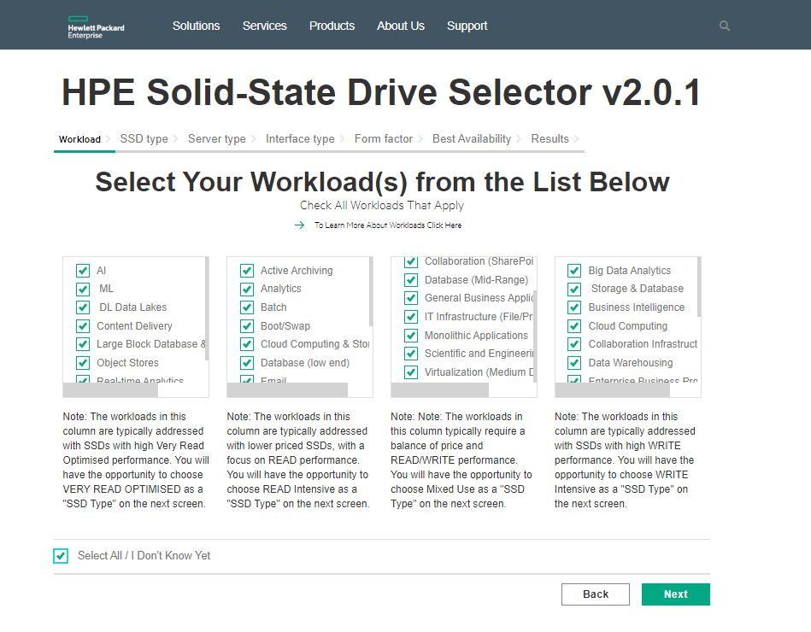**Fig 1. 2 Workload Page (c)**

* 1. Based on the workload option customer will redirect to SSD type page, based on your previous selection this page will auto select the SSD type like Very Read optimization/ Read Intensive /read write optimization/ Write Intensive,

Here we can change our SSD type also by clicking the checkbox. Refer SSD Fig 1.4

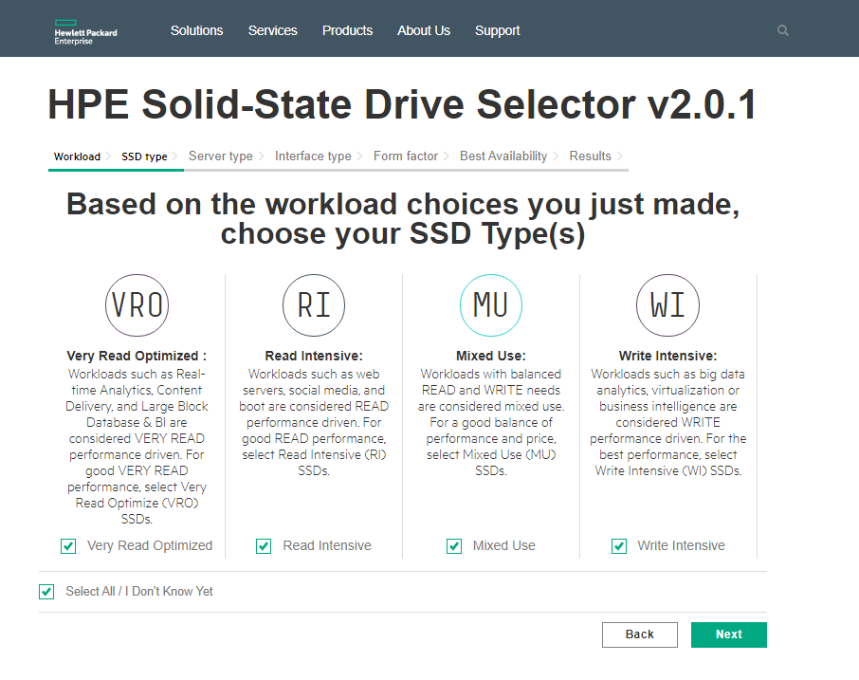

**Fig 1.4 SSD Page**

* 1. After selecting the SSD type the Page will redirect to server type. Here people can select their server type based on that server model they can select. Refer Fig 1.5 Server Type

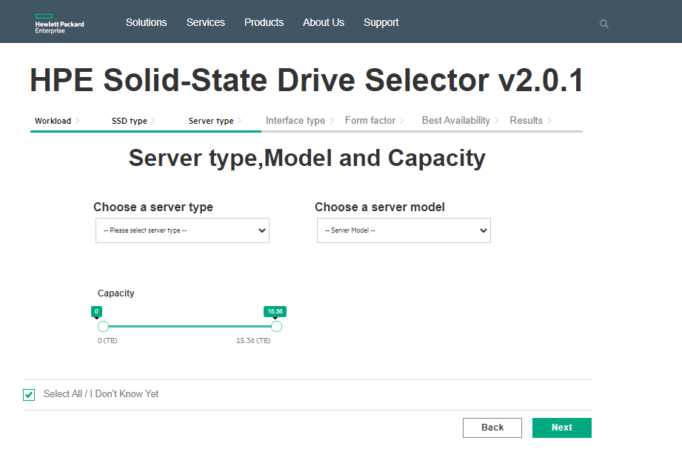

**Fig 1.5: Server Type**

Click on “Please server type” drop down, where user need to select the server type based on the Good, Best and Better suggested in the Server Type page refer 1.5 Server Type (a)

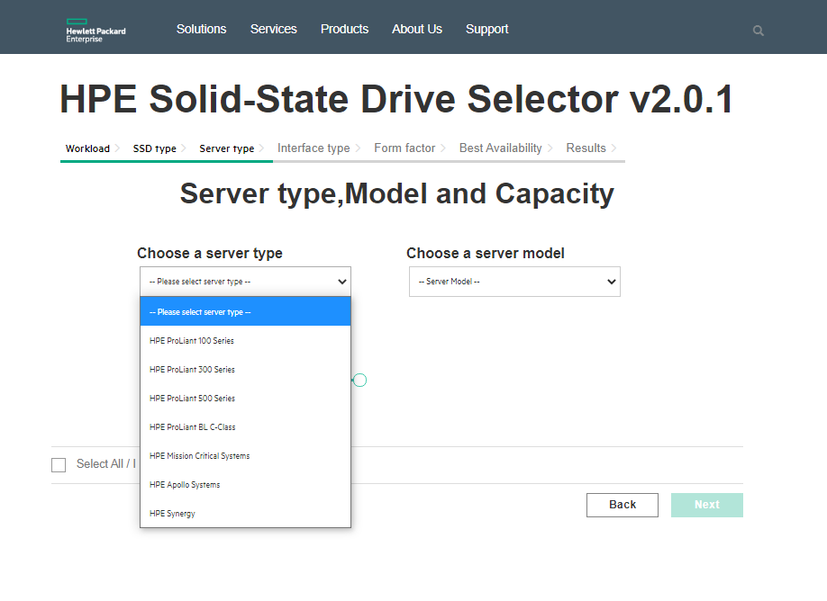

**Fig 1.5 Server Type (a)**

Select the Server Type refer Fig 1.5 Server Type (a), After selecting the server, select the Server Model from the drop down. If Server model is available, then Server Model drop down gets enabled. refer Fig 1.5 Server Type (b)

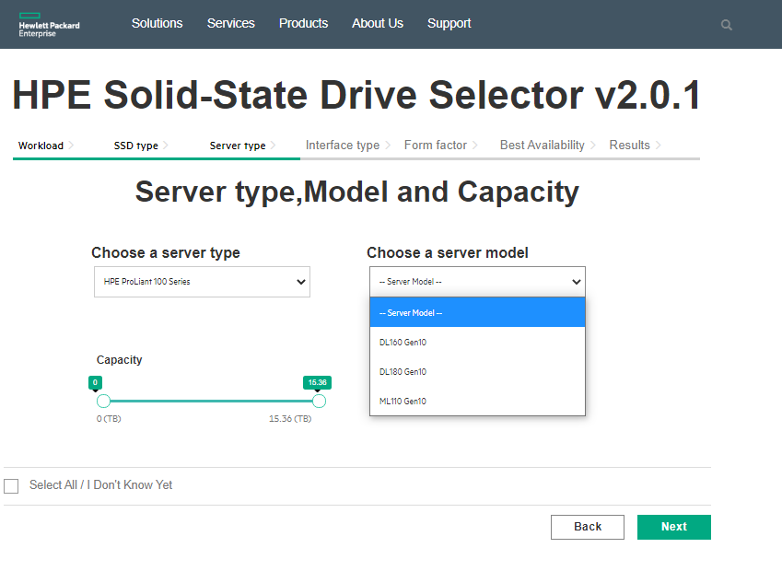

**Fig 1.5 Server Type (b)**

1.6 once the server type selection completed by clicking on next button user will move on to capacity page. Based on server type by default it will show the maximum capacity. By adjusting the slider, we can specify the maximum capacity we need. Refer Capacity Page Fig 1.6

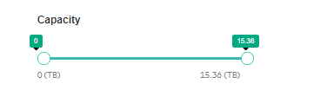

**Fig 1.6 Capacity (a)**

Based workload capacity of the SSD will be displayed, here user modified the SSD capacity from minimum to maximum based on the requirement. Modifying the SSD Capacity by sliding from Maximum to Minimum and Vice Versa. Refer Fig 1.6 Capacity Page (b) and Fig 1.6 Capacity Page (c)

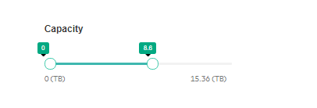

**Fig 1.6 Capacity (b)**



**Fig 1.6 Capacity (c)**

1.7 Once the Capacity is selected click on Next button, it redirects to Interface page, where options are auto selected based on the previous configurations. And other options are in disable mode which does not support for the configurations. Refer Fig 1.7 Interface Page

Interface Page options are

1. **SATA**: - Serial ATA is a bus interface that connects host bus adapters to storage devices such as solid-state drives. HPE SATA SSDs support 6 Gbit/s for scalable performance. SATA is good for direct connect use cases
2. **SAS**: - Serial Attached SCSI is a performance and bandwidth improvement over SATA that supports full-duplex and other features. SAS is good at sharing links, and thus SAS SSDs do well behind expanders. HPE SAS SSDs support 12 Gbit/s.

**3. NVMe: -** NVMe gives you the best performance and best system latency, placing the NAND on the PCIe bus with the system memory and the processor and NVMe offers four to eight lanes of high performance and bandwidth. NVMe, or Non-Volatile Memory Express, is a from-the-ground-up specification that focuses on efficiency, interoperability, scalability, and high performance.

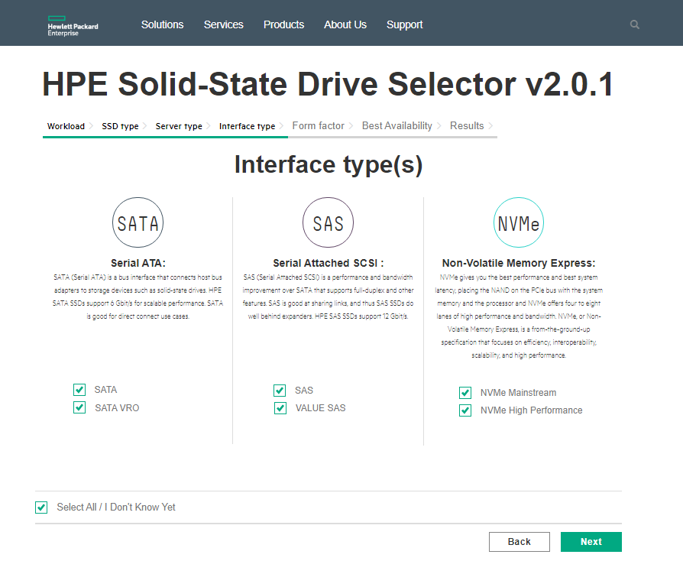

**Fig 1.7 Interface Page**

In the Interface page, options are auto selected and editable.

1.8 Once the Next button is clicked in the Interface Page, it redirects to Form Factor Page, where Options are auto selected based on the previous configurations. And other options are in disable mode which does not support for the configurations. Refer Fig 1.8 Form Factor

Form Factor SSDs are

3.5” LFF: - Large Form Factor

2.5” SFF: Small Form Factor

Add-In Card

M.2

M.2 Enablement Kit

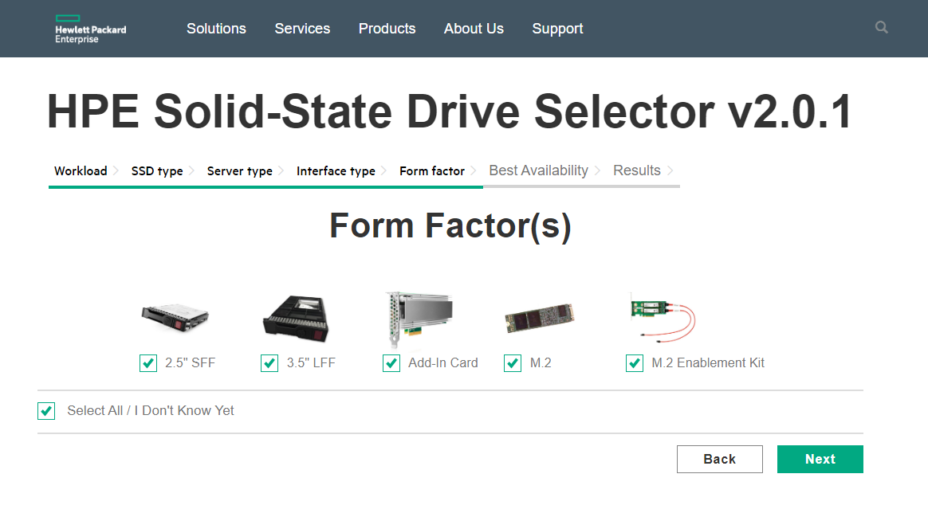

**Fig 1.8 Form Factor**

In the form factor page, Options are auto selected and editable.

1.9 Once Next button is clicked in the Form Factor Page, it redirects to Best Availability page, this page has two options such as,

a. Mainstream

b. Non-Mainstream

Refer Fig 1.9 Best Availability (a)

By choosing these options Results are displayed based on the option selected in the Best Availability page. Refer Fig 1.9 Best Availability (a)

Mainstream options are selected then High-Performance SSDs are displayed in the Results.

Non-Mainstream option is selected then SSDs are displayed with Low Performance.

Both options are selected through “Select All/I Don’t Know Yet “option or individually user can select the Mainstream and Non-Mainstream SSD Category. Fig 1.9 Best Availability (c)

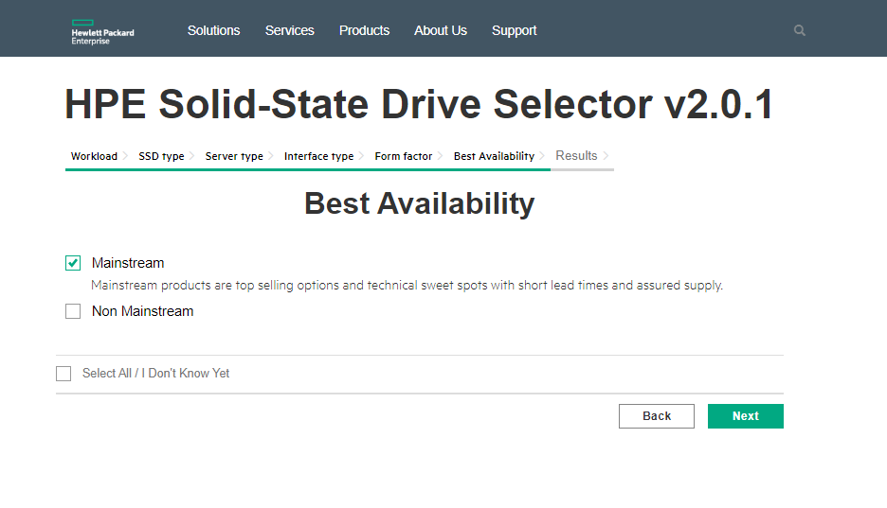

**Fig 1.9 Best Availability (a)**

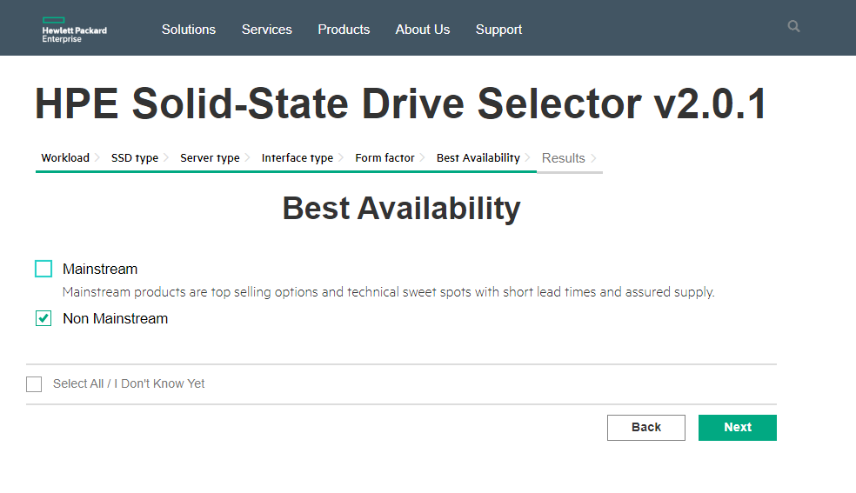

**Fig 1.9 Best Availability (b)**

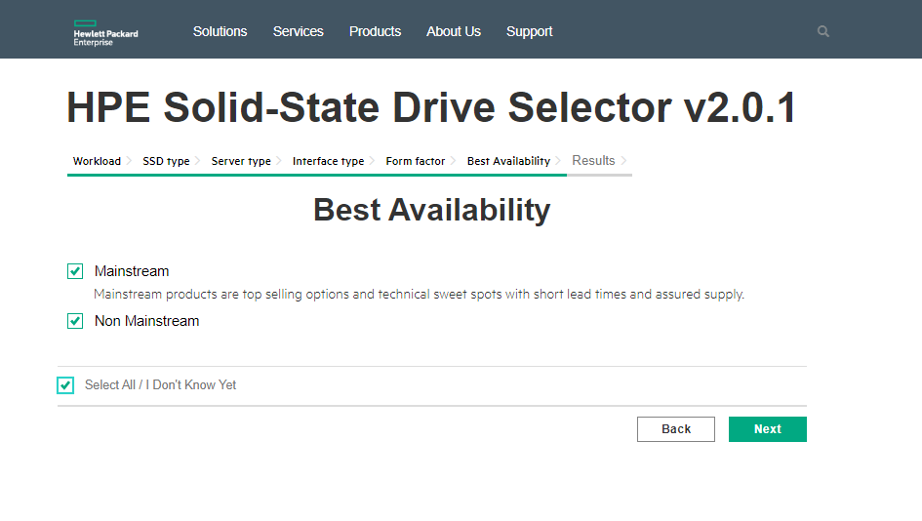

**Fig 1.9 Best Availability (c)**

1.10 Once the Next button is clicked in the Best Availability page, Finally the result page will display the suggested SSDs based on our previous selections.

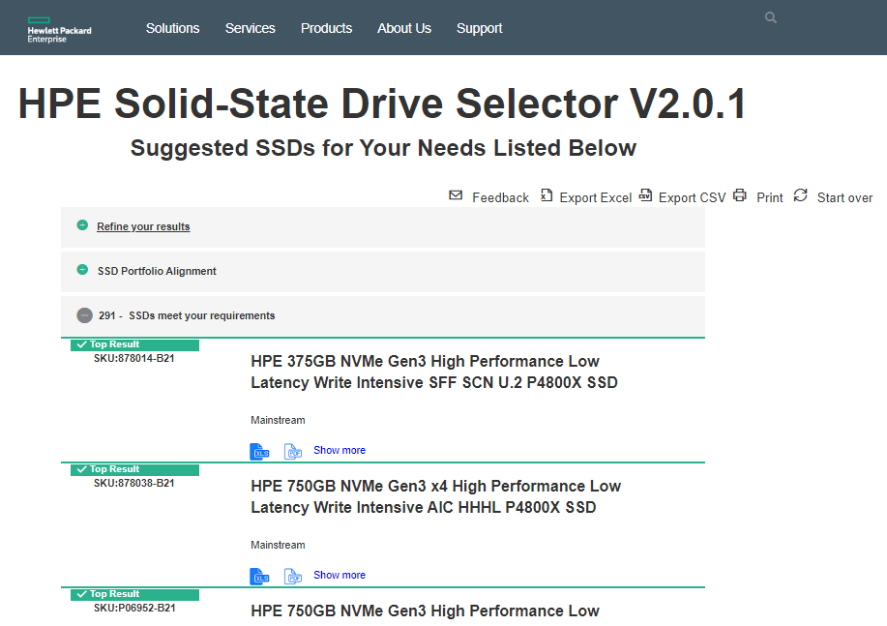

**Fig 1.10 Results Page (a)**

In the Results Page Suggested SSDs are displayed based on the Previous Selections.

In the Result page consist of three options such as

1. Refine Your Results
2. SSD Portfolio Alignment
3. SSDs meets your requirements.

Click on “Refine Your Results” link, then all selected options are displayed in the page. Such as Refer Image Fig 1.10 Results Page (b)

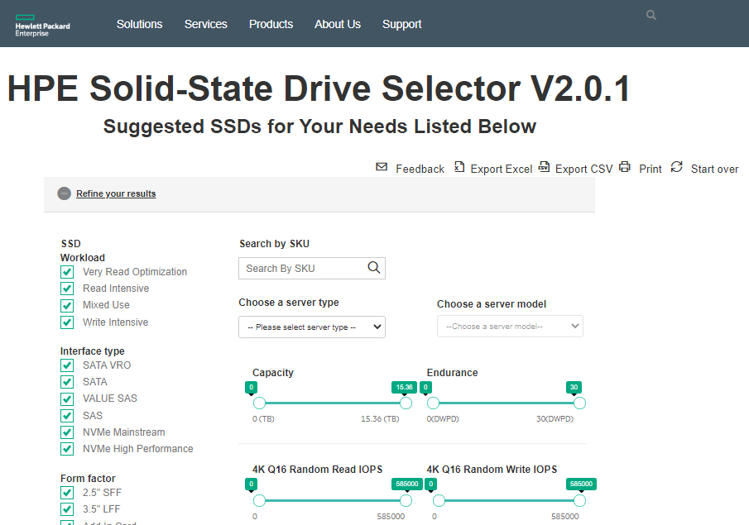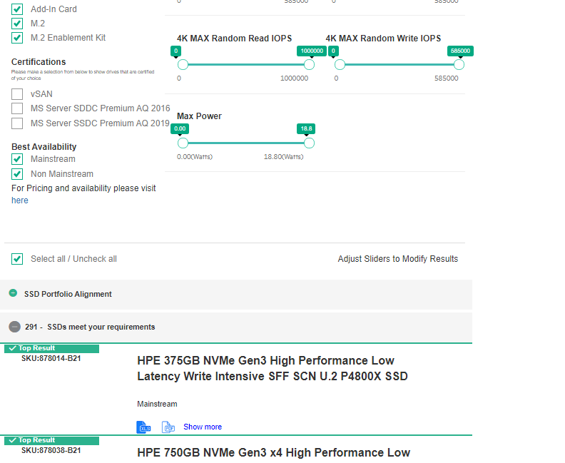

**Fig 1.10 Results Page (b)**

Results are displayed based on the previous selections and Results can be modified by below options,

1. Search SSDs through SKU Keys, Refer Fig 1.10 Results Page (c)

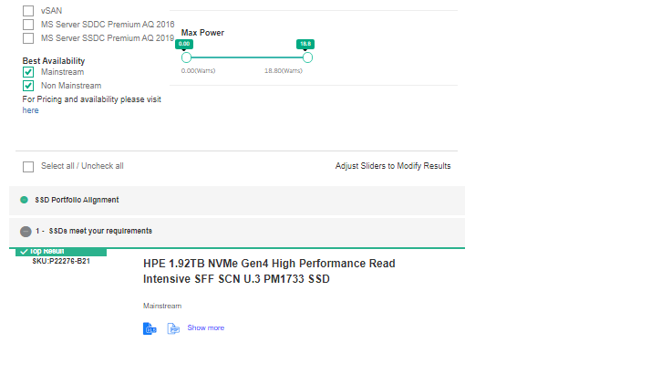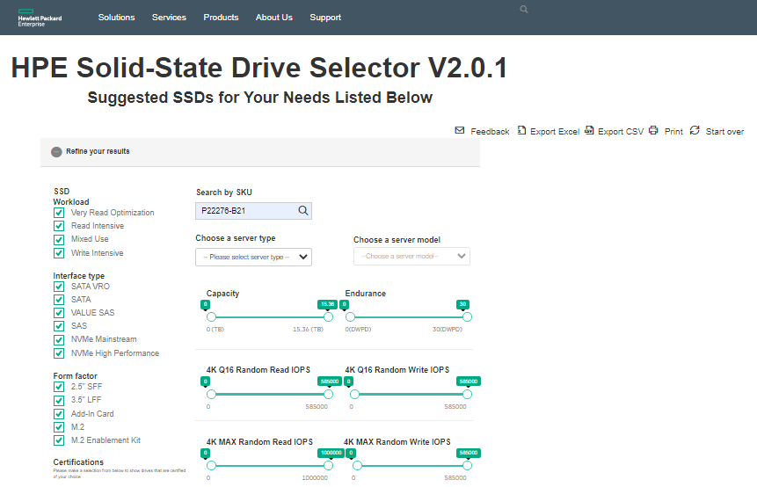

**Fig 1.10 Result Page (c)**

1. Select the Server Type from the Drop down, Refer Fig 1.10 Server Type (d)

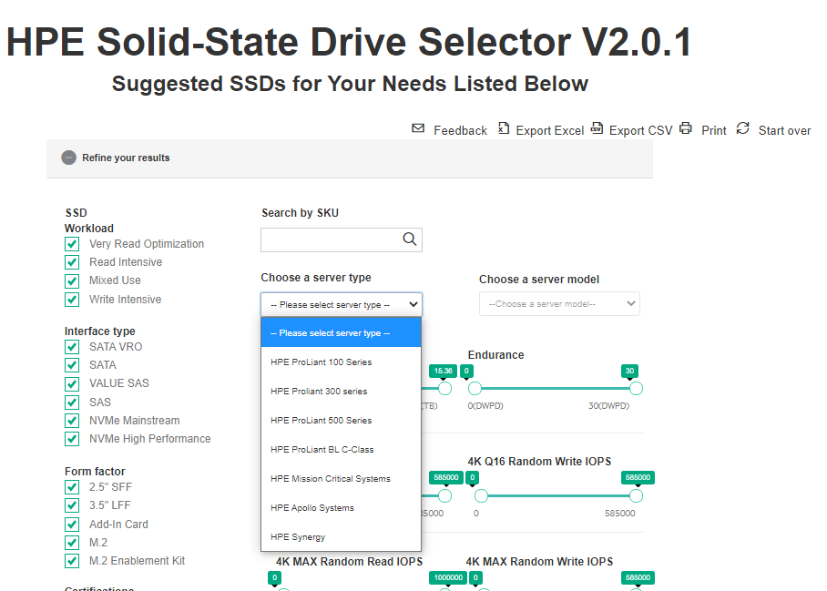

**Refer Fig 1.10 Server Type (d)**

1. Select the Server Model from the Drop down, Refer Fig 1.10 Server Model (e)

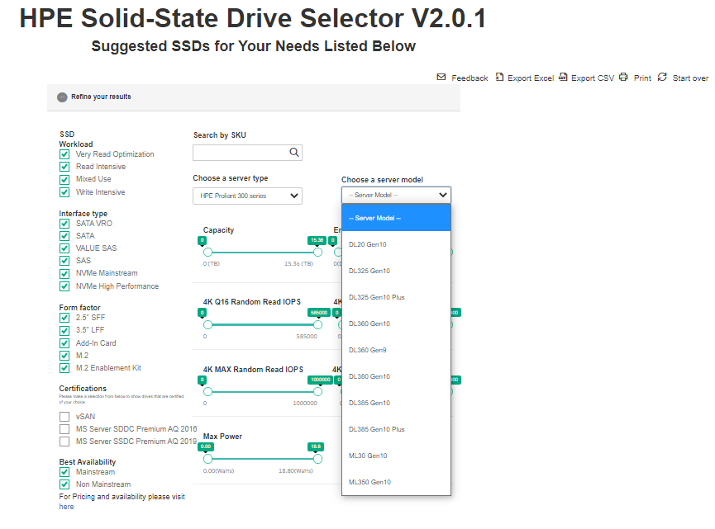

**Refer Fig 1.10 Server Model (e)**

1. Results can be modified by selecting and deselecting check box in the SSD types such as Read Intensive/ Mixed Use/ Write Intensive and Very Read Optimized. Based on selected SSD type Results are displayed.
2. Results can be modified by selecting and deselecting check box in the Interface types such as SAS/ Value SAS/SATA/SATA VRO and NVMe. Based on selected Interface type Results are displayed.
3. Results can be modified by selecting and deselecting check box in the Form Factor types such as Add-In Card/ 3.5” LFF/M.2/M.2 Enablement Kit and 2.5” SFF Based on selected Form Factor Type Results are displayed.
4. Results can be modified by selecting and deselecting check box in the Best Availability types such as Mainstream and Non-Mainstream Based on selected Best Availability Type Results are displayed.
5. Results can be modified by selecting and deselecting check box in the Select all applicable Checkboxes above, based on selected type Results are displayed.

Click on “SSD Portfolio Alignment”, HPE Storage Options- SSD Portfolio Alignment Image displays in the Result page. Refer Fig 1.10 Results Page (f)

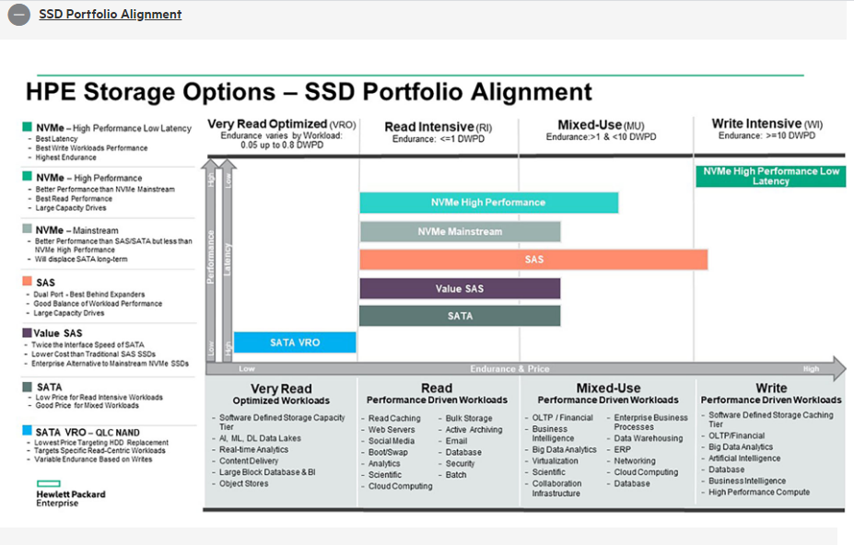

**Fig 1.10 Results Page (f)**

Click on “SSDs meets your requirements”, then Results will be closed, again click on SSDs meets your requirements link, Results will be displayed. Refer Fig 1.10 Results Page (g)

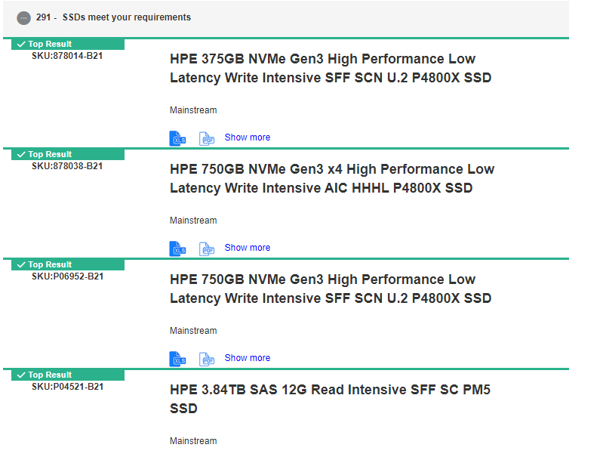

**Fig 1.10 Results Page (g)**

In the Individual SSD type, click on Show More Link, it shows complete specification of Selected SSDs and Image will be displayed. Refer Fig 1.10 Results Page (g)

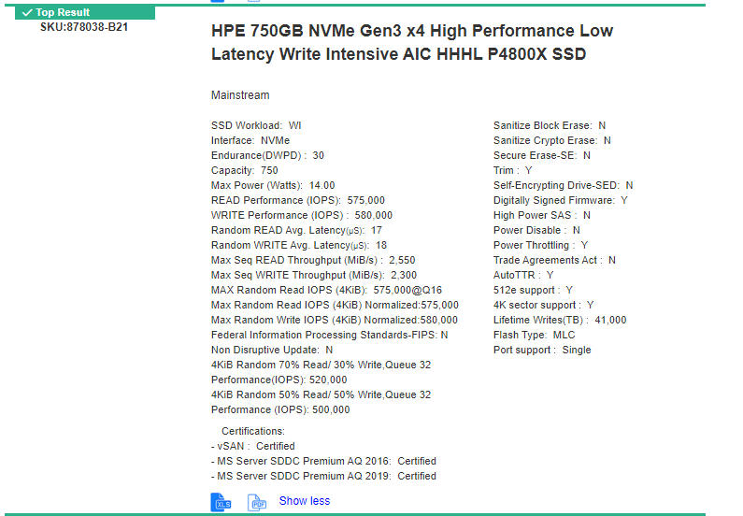

**Fig 1.10 Results Page (g)**

In the Individual SSD type, click on Show Less Link, then Selected SSD specification is closed and “XLS”,”PDF” and Show More Link. Refer Fig 1.10 Results Page (h)



**Fig 1.10 Results Page (h)**

In the Individual SSD type, click on “XLS”, Excel File will be downloaded with SSD specification, and click on “PDF”, PDF file will be downloaded with SSD specification,

Complete SSDs Specification can be downloaded in the Excel format/PDF format by clicking the **Share Excel/ Share PDF** icon in the Result page. Refer Fig 1.10 Results Page(i)

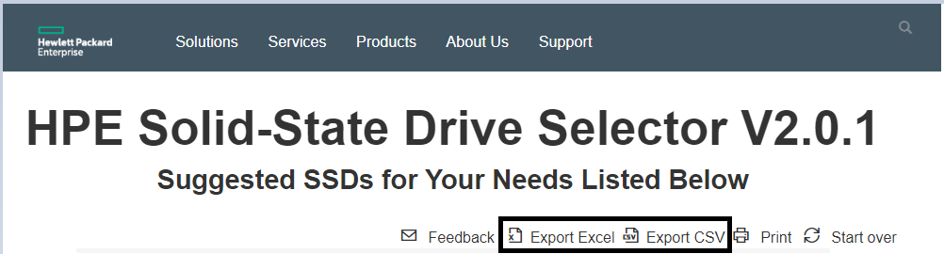

**Fig 1.10 Results Page (I)**

The User can print the Suggested SSDs in the Result page by clicking on Print Icon, where can save the SSDs in the PDF file. Refer Fig 1.10 Results Page(j)

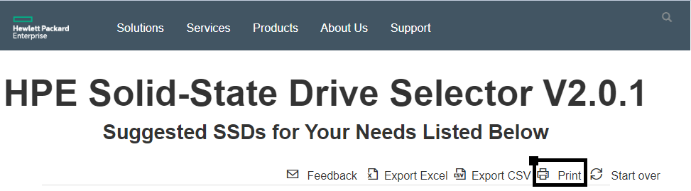

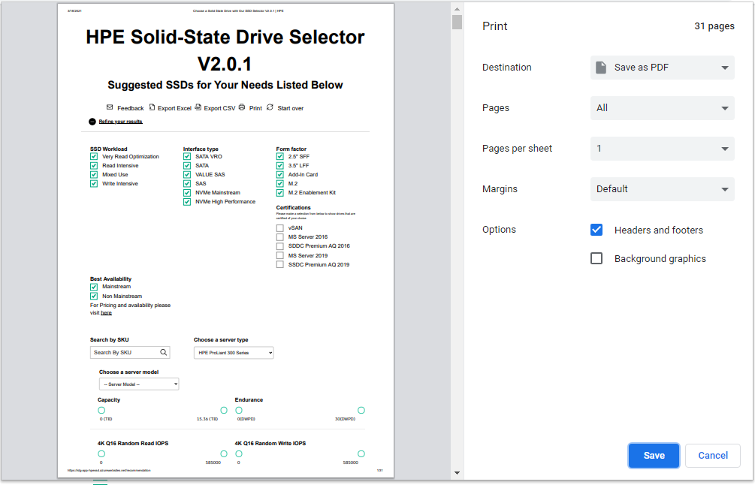

**Fig 1.10 Results Page(j)**

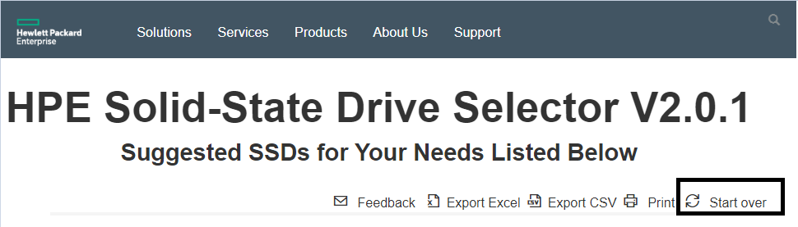The User can go back to Home page by click on Start over Icon. Refer Fig 1.10 Results Page(k)

**Fig 1.10 Results Page(k)**

The User can send the Feedback to hpe support team on click on Feedback Icon, where it opens the select email option.

**System Requirements**

**OS: -** Latest Windows Version

**Browsers: -** Google Chrome and Microsoft Edge Supported

**Image Represents SSD Selector Flow**

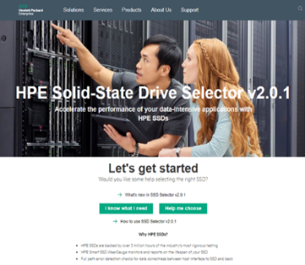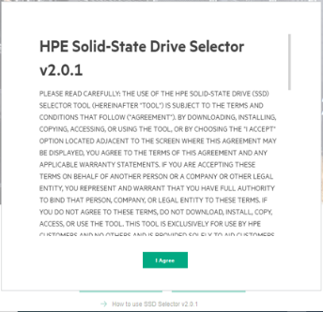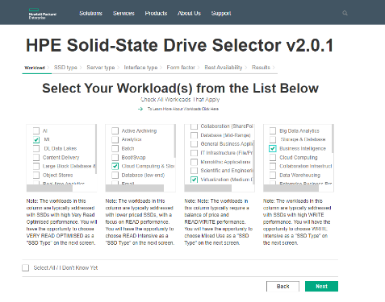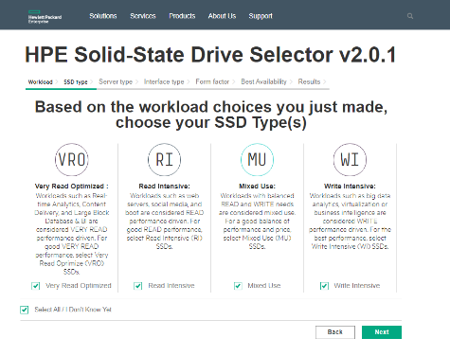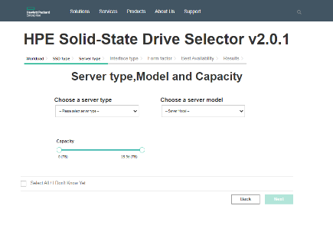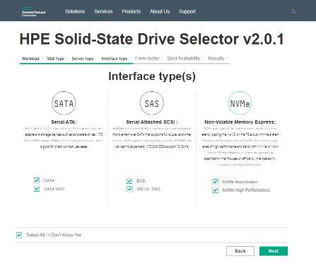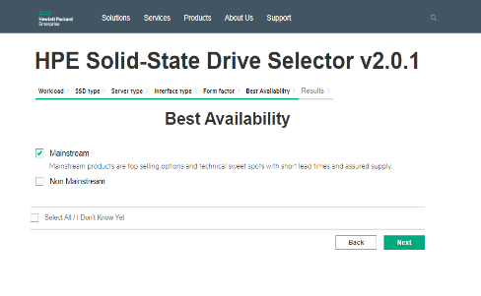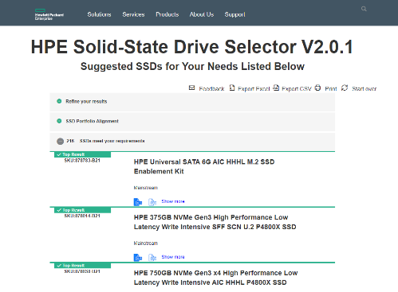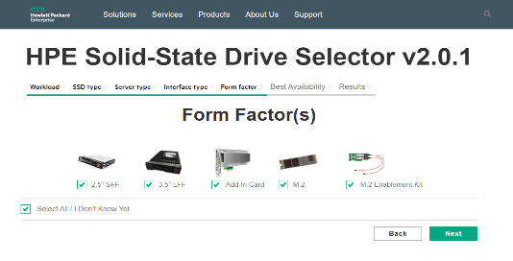

**I Know What I Need**

* 1. 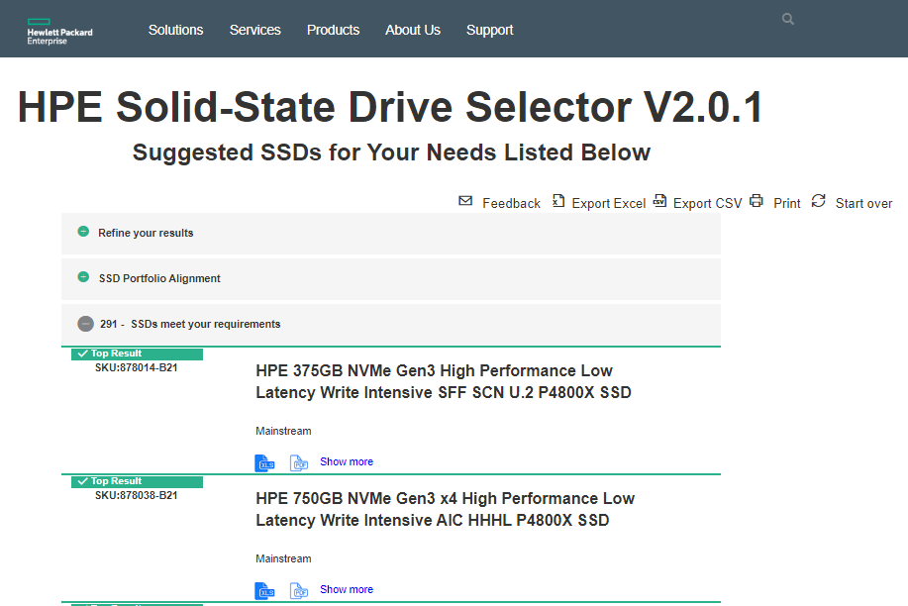Results can see directly see from Home Page by clicking on “**I Know What I need**” Button, Refer 2.1 Result Page (a)

**Fig 2.1 Results Page (a)**

* 1. Results can be filtered on click on “**Refine your results**” Link, Refer 2.2 Result Page (b)



**Fig 2.2 Result Page (b)**

* 1. Only Read Intensive SSD Results can be viewed by deselecting the Mixed Use, Write Intensive and Very Read optimized check boxes. Then only Read Intensive SSD Results are displayed. Similarly, it applies to Interface Types, Form factor, Certifications and Best Availability, based on the selected checkboxes SSD Results are displayed. Refer 2.3 Result Page (c)

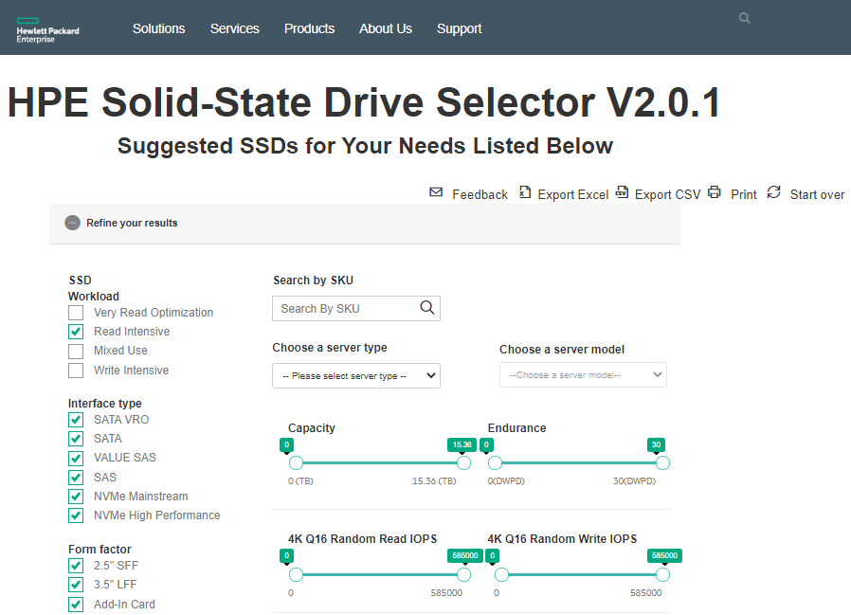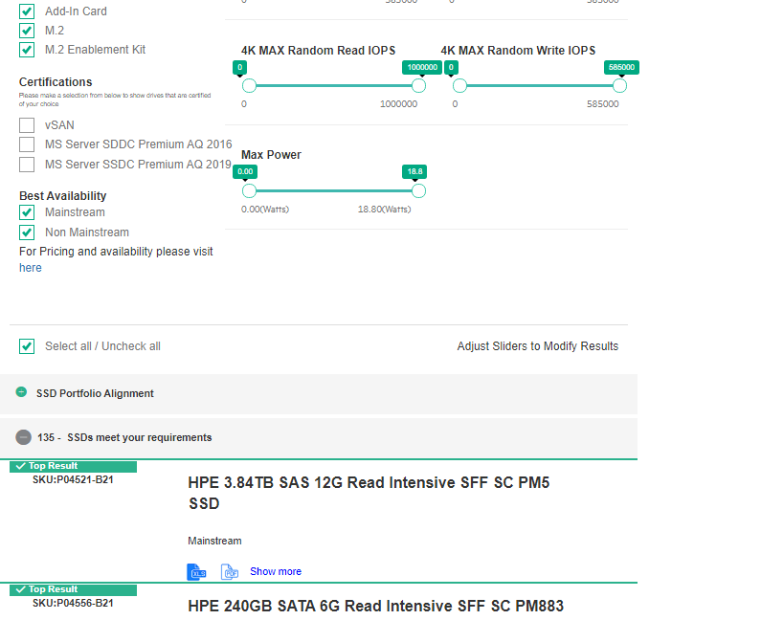

**Fig 2.3 Result Page (c)**

* 1. In the Interface type, deselect the SAS Checkbox then selected checkboxes combination results are displayed, Refer 2.4 Result Page (d)

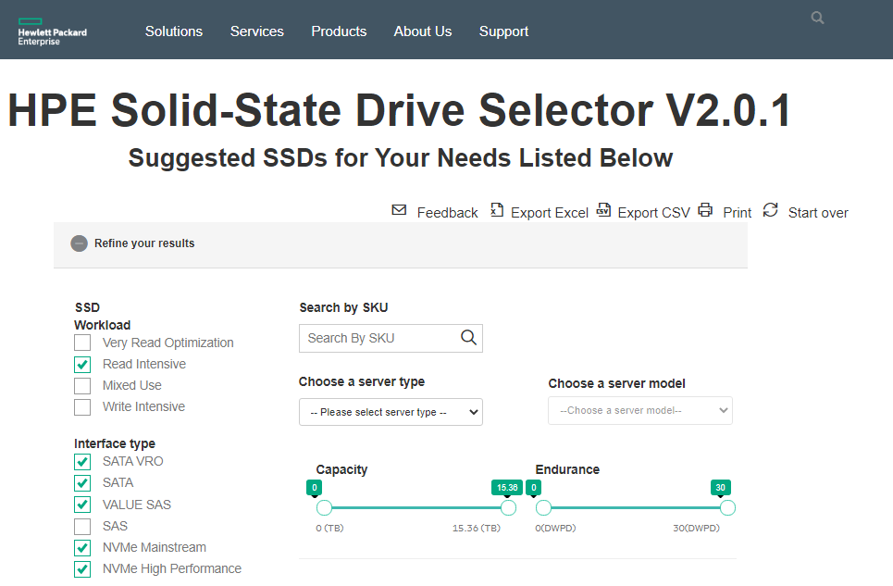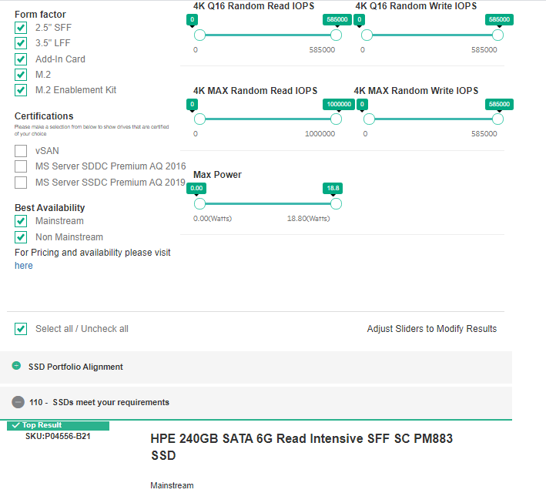

**Fig 2.4 Result Page (d)**

* 1. If results are not found based on the selection, then message will be displayed “There are no results based on your selection. Please select different attributes or start over”

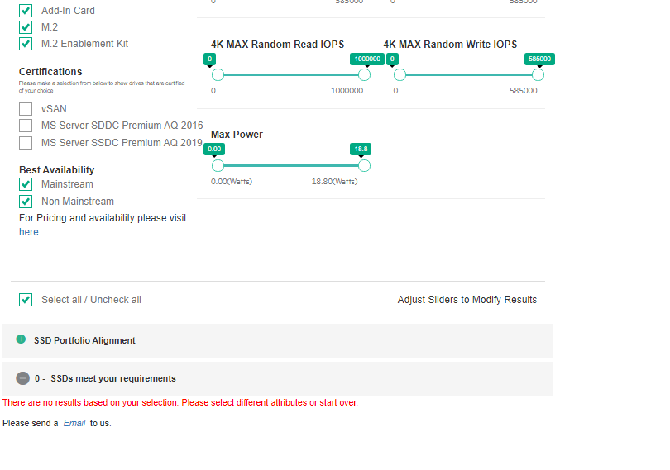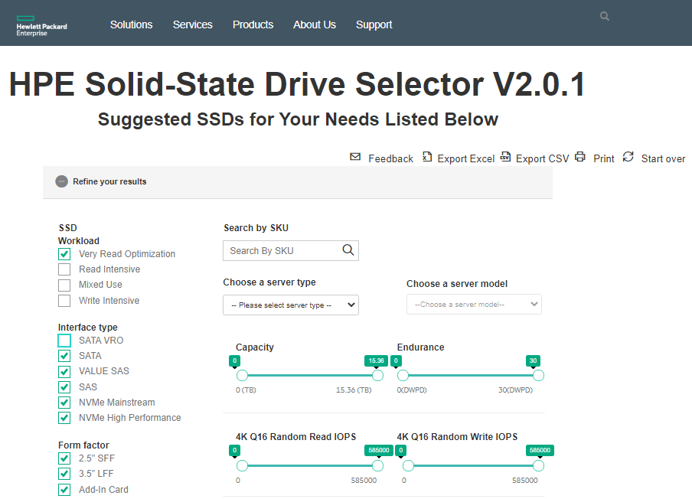

**Fig 2.4 Result Page (e)**